**Title Of the Project:**

**Forest Cover Type Prediction Using Random Forest Classifier**

**Introduction**

This project aims to develop a machine learning model capable of predicting the forest cover type based on various environmental features such as elevation, distance to hydrology, slope, and others. The project is based on supervised learning using classification techniques, particularly focusing on a Random Forest Classifier. The dataset used for this project contains several features related to geographical and environmental data, and the goal is to predict which type of forest cover is present at a particular location.

**Abstract**

The objective of this project is to develop a predictive system for forest cover type classification based on geospatial data gathered from a 30m x 30m area in the Roosevelt National Forest of northern Colorado. The dataset comprises various attributes that characterize the physical features and environmental conditions of the land, such as elevation, slope, aspect, and distances to hydrology and roadways. Additionally, the dataset includes hillshade indices for different times of day, as well as binary indicators for wilderness areas and soil types. The classification task involves categorizing forest cover into seven distinct types: Spruce/Fir, Lodgepole Pine, Ponderosa Pine, Cottonwood/Willow, Aspen, Douglas-fir, and Krummholz.

**1. Problem Definition**

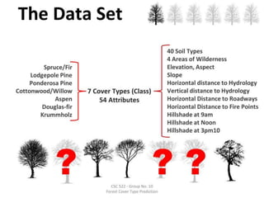The main problem is to predict the forest cover type, given a set of environmental features. There are seven different forest cover types to classify, as defined by the dataset. The cover types are:

1. **Spruce/Fir**
2. **Lodgepole Pine**
3. **Ponderosa Pine**
4. **Cottonwood/Willow**
5. **Aspen**
6. **Douglas-fir**
7. **Krummholz**

Each record in the dataset represents a specific geographical point with several numerical attributes like elevation, slope, and distances to hydrological or road features. Our task is to build a predictive model that can learn from these features and classify the data points into one of the seven cover types.

**2. Dataset Overview**

The dataset is structured with several features that are critical for the prediction task:

**Key Features:**

* **Elevation**: Elevation of the point in meters.
* **Aspect**: Compass direction the slope faces in degrees.
* **Slope**: Slope of the point in degrees.
* **Horizontal_Distance_To_Hydrology**: Horizontal distance to the nearest surface water feature.
* **Vertical_Distance_To_Hydrology**: Vertical distance to the nearest surface water feature.
* **Horizontal_Distance_To_Roadways**: Horizontal distance to the nearest roadway.
* **Hillshade_9am, Hillshade_Noon, Hillshade_3pm**: Hillshade indices at different times of day.
* **Horizontal_Distance_To_Fire_Points**: Horizontal distance to the nearest wildfire ignition point.

The target variable is **Cover_Type**, which represents the type of forest cover.

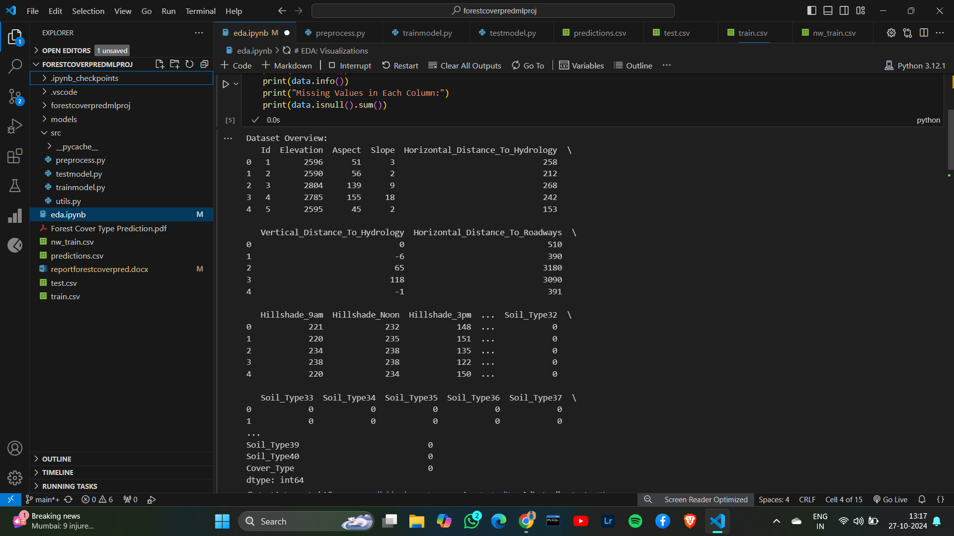

**3. Workflow Breakdown**

**a) Data Preprocessing (preprocess.py)**

Preprocessing is one of the most critical stages in machine learning projects. The raw dataset cannot be directly fed into a machine learning model, so several steps are applied:

* **Data Loading**: The dataset is loaded from a CSV file using pandas.

Python code:

def load_data(filepath):

return pd.read_csv(filepath)

* **Scaling Continuous Features**: Continuous features like Elevation, Slope, Horizontal_Distance_To_Hydrology, etc., need to be standardized to ensure the model can effectively learn from them. StandardScaler is used to scale these features so that each has a mean of 0 and a standard deviation of 1.
* **Preprocessing Pipeline**:
  + Features (X) and the target (y) are separated.
  + The continuous features are scaled.
  + The transformed data is returned for further model training.

This step ensures that the data is well-prepared for the machine learning model by handling feature scaling and separating features from the target variable.

Python code:

data = pd.read_csv('train.csv')

continuous_features = [

    'Elevation',

    'Aspect',

    'Slope',

    'Horizontal_Distance_To_Hydrology',

    'Vertical_Distance_To_Hydrology',

    'Horizontal_Distance_To_Roadways',

    'Hillshade_9am',

    'Hillshade_Noon',

    'Hillshade_3pm',

    'Horizontal_Distance_To_Fire_Points']

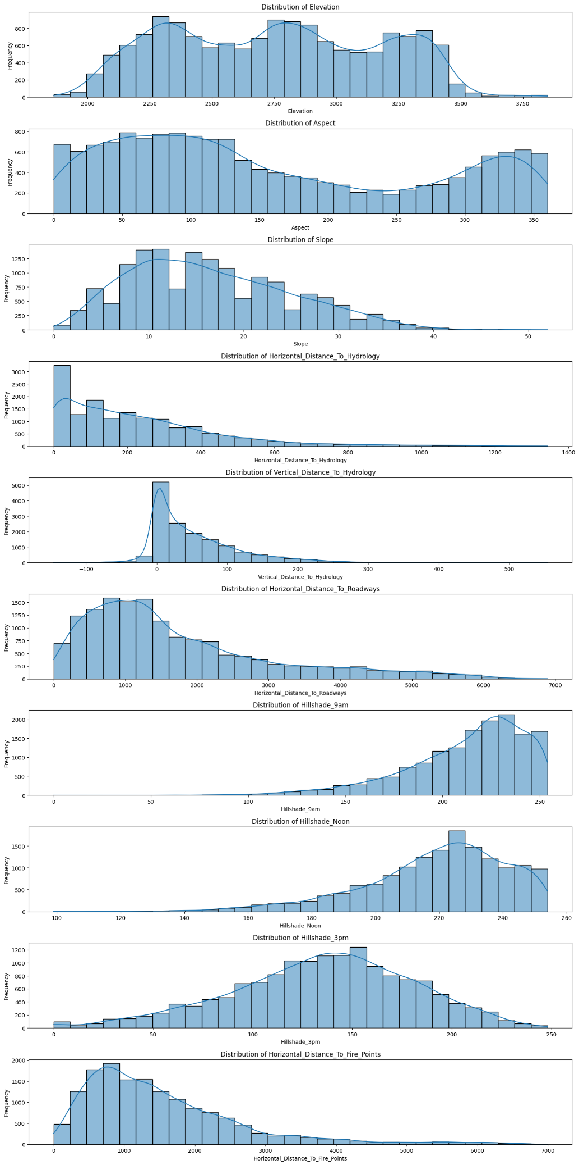Distribution of Continuous features:

These are the continuous features by cover_type:

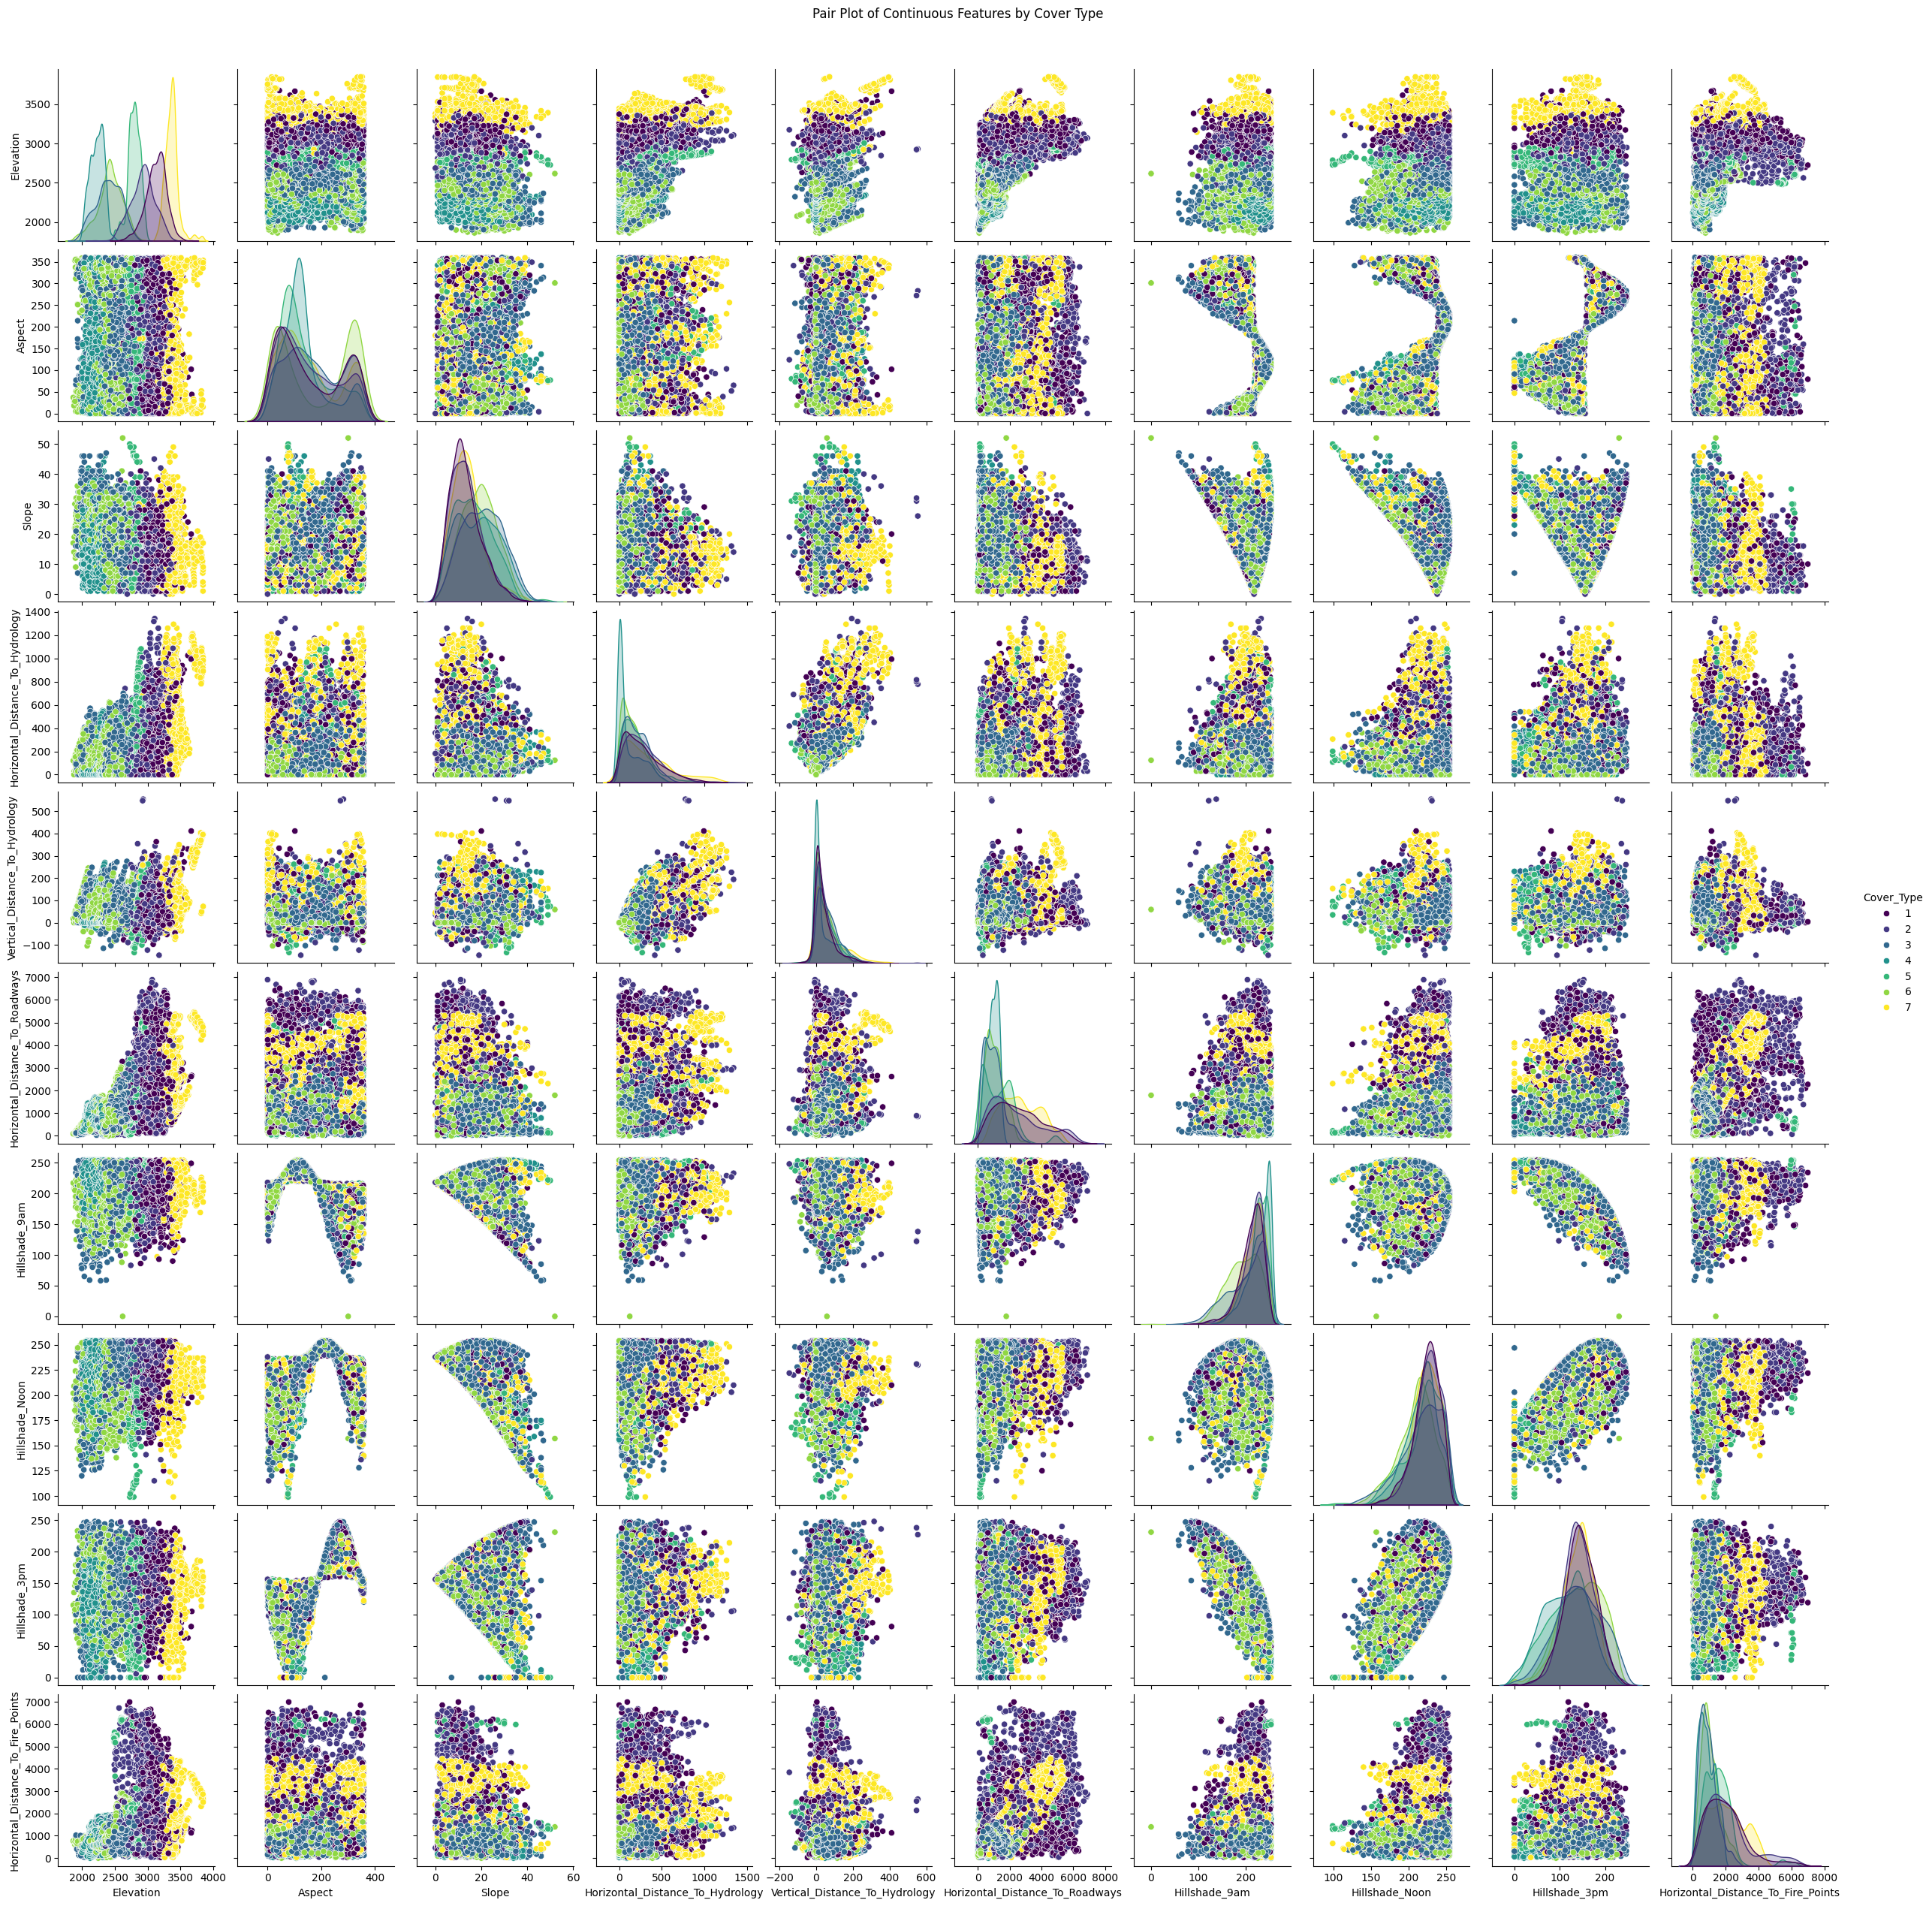

Count of Cover Types:

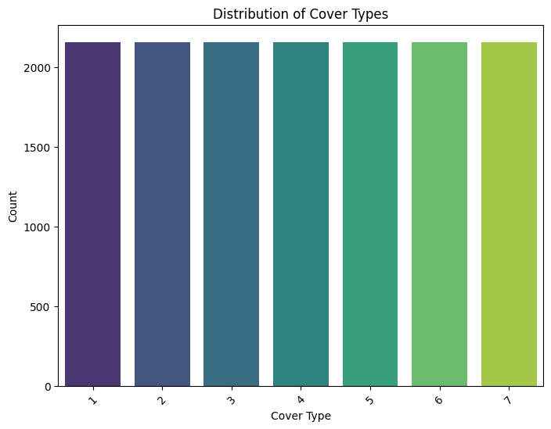

**b) Model Training (trainmodel.py)**

After preprocessing the data, the next step is to train the machine learning model. This step involves splitting the data into training and testing sets, training the model on the training set, and evaluating it on the test set.

The size of the train.csv is 15,120 Rows ,56 Columns

* **Train-Test Split**: The dataset is split into 70% training data and 20% testing data using train_test_split from Scikit-learn.

Python code:

X_train, X_test, y_train, y_test = train_test_split(X, y, test_size=0.2, random_state=42)

* **Model Choice**: A Random Forest Classifier is chosen for this task due to its effectiveness with structured data and ability to handle large datasets with many features.

Python code:

model = RandomForestClassifier()

model.fit(X_train, y_train)

* **Model Evaluation**: After training, predictions are made on the test data, and performance metrics are calculated. The classification_report function generates precision, recall, and F1-score for each class (forest cover type).

Python code:

predictions = model.predict(X_test)

print(classification_report(y_test, predictions))

Classification Report:

precision recall f1-score support

1 0.79 0.80 0.79 421

2 0.83 0.71 0.77 438

3 0.88 0.84 0.86 428

4 0.93 0.98 0.95 449

5 0.89 0.95 0.92 416

6 0.87 0.90 0.89 432

7 0.95 0.97 0.96 440

accuracy 0.88 3024

macro avg 0.88 0.88 0.88 3024

weighted avg 0.88 0.88 0.88 3024

Accuracy: 0.8799603174603174

* **Confusion Matrix**: A confusion matrix is plotted to visualize the model’s classification performance.

Python code:

conf_matrix = confusion_matrix(y_test, predictions)

sns.heatmap(conf_matrix, annot=True, fmt="d")

plt.show()

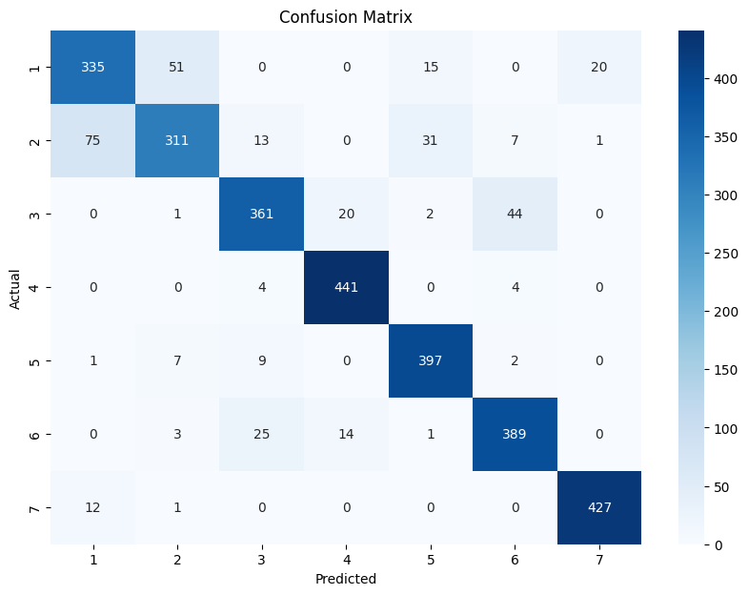

**c) Model Tuning (Hyperparameter Optimization)**

To further improve the model's performance, hyperparameter tuning is performed using RandomizedSearchCV. This technique searches for the best combination of parameters by randomly sampling from a parameter grid.

If we want to improve the model it is used further.

* **Parameter Grid**: A dictionary specifying possible values for key hyperparameters like the number of trees (n_estimators), maximum tree depth (max_depth), and minimum samples required to split a node (min_samples_split).

Python code:

param_grid = {

'n_estimators': [100, 200, 300],

'max_depth': [10, 20, 30],

'min_samples_split': [2, 5, 10],

}

* **Random Search**: The best parameters are found through cross-validation, and the model is refit with the optimal parameters.

Python code:

rf_random = RandomizedSearchCV(estimator=model, param_distributions=param_grid, cv=3)

rf_random.fit(X_train, y_train)

**d) Model Saving**

Once the model is trained and tested we should save it in some file or any others.

Here I have saved it in csv file better understanding purpose.\

Python code:

X_train_df = pd.DataFrame(X_train, columns=X.columns)

y_train_df = pd.DataFrame(y_train, columns=['Cover_Type'])

train_data = pd.concat([X_train_df, y_train_df], axis=1)

train_data.to_csv('trai.csv', index=False)

X_test_df = pd.DataFrame(y_test, columns=X.columns)

y_test_df = pd.DataFrame(y_test, columns=['Cover_Type'])

test_data = pd.concat([X_test_df, y_test_df], axis=1)

test_data.to_csv('tes.csv', index=False)

**4. Results and Evaluation**

The Random Forest Classifier performed well on the classification task. The following metrics were used to evaluate the model:

* **Accuracy**: The percentage of correctly predicted forest cover types.
* **Precision, Recall, F1-score**: Detailed metrics for each class to evaluate the performance for each cover type.
* **Confusion Matrix**: A matrix to visualize the distribution of true positives and false positives across the seven cover types
* **Saving the predictions**: The predictions performed on testing data is saved as predictions.csv file here we can check the data how effectively the data is being predicted.

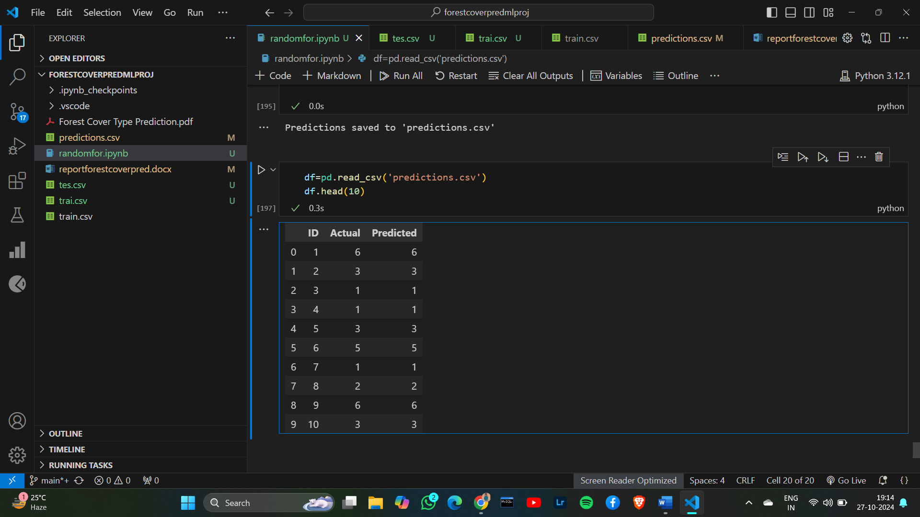

**5. Conclusion**

This project successfully developed a machine learning pipeline for predicting forest cover types based on geographical and environmental features. The project followed a structured workflow, starting from data preprocessing, model training, evaluation, and hyperparameter tuning, to finally testing the model on new data. Random Forest was chosen as the classification model due to its robustness and accuracy in handling structured data.

This pipeline can now be deployed for real-world applications in forestry management or environmental studies where predicting forest cover types is crucial.